Merge Intervals



* Sort the intervals
* And compare the ith intervals and marge it.



Rotate Matrix Algo

* Transpose to Matrix
* Reverse the all row

Transpose Matrix is making row to column and column to row

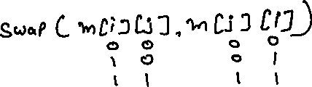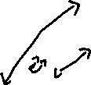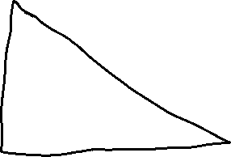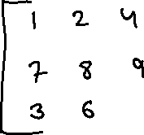

After transpose sort the all rows.

